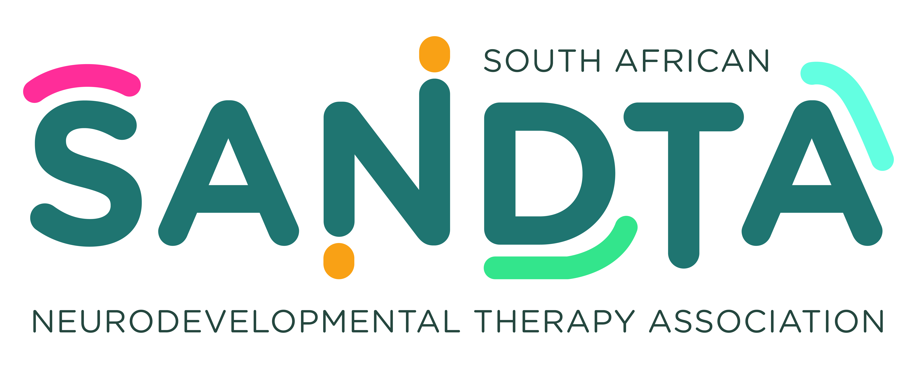
2023 Application Form
Introduction to the Clinical Analysis, Treatment and Management of Children with Cerebral Palsy
SANDTA Members: R 5 300-00, Non SA Members and Africa Therapists: R 5 800-00, International Participants: R 6 300-00

PERSONAL INFORMATION
Surname: ________________________________ Name: __________________________________
Postal Address: __________________________________________________________________________
________________________________________________________________________________________
Email address: __________________________________________________________________________
Work number: _______________________________ Cell nr: __________________________________

YES
NO

Are you a member of SANDA? Membership number: _______________________
CURRENT EMPLOYMENT
Institution / Hospital: ____________________________ City/Town: ______________________________
Province: ___________________________________ Country: _________________________________
CP case load:_____________________________________________________________________________
OT
PT

SLT

Profession: *HPCSA Registration nr: _______________________
*If not working in RSA, name of the country where you are registered and registration nr: _________________

International Applicants: Proof of registration with Professional Council/Qualification Certificate attached
Your name as you want it printed on the certificate: (Please print clearly) _____________________________
PLEASE indicate which Introductory Course you want to apply for and PLEASE indicate your first and second choice in the last column.
Courses 2023:
VENUE | DATE | Tick where applicable
Durban  Venue: KZN Children’s Hospital | 28 August – 1 September
Cape Town  Venue: Eros School | 11 – 15 September
Pretoria  Venue: Alma School | 10 - 14 July
Send the completed form to: E-mail: sandta@internext.co.za Enquiries: 083 229 0456

